For Immediate Release
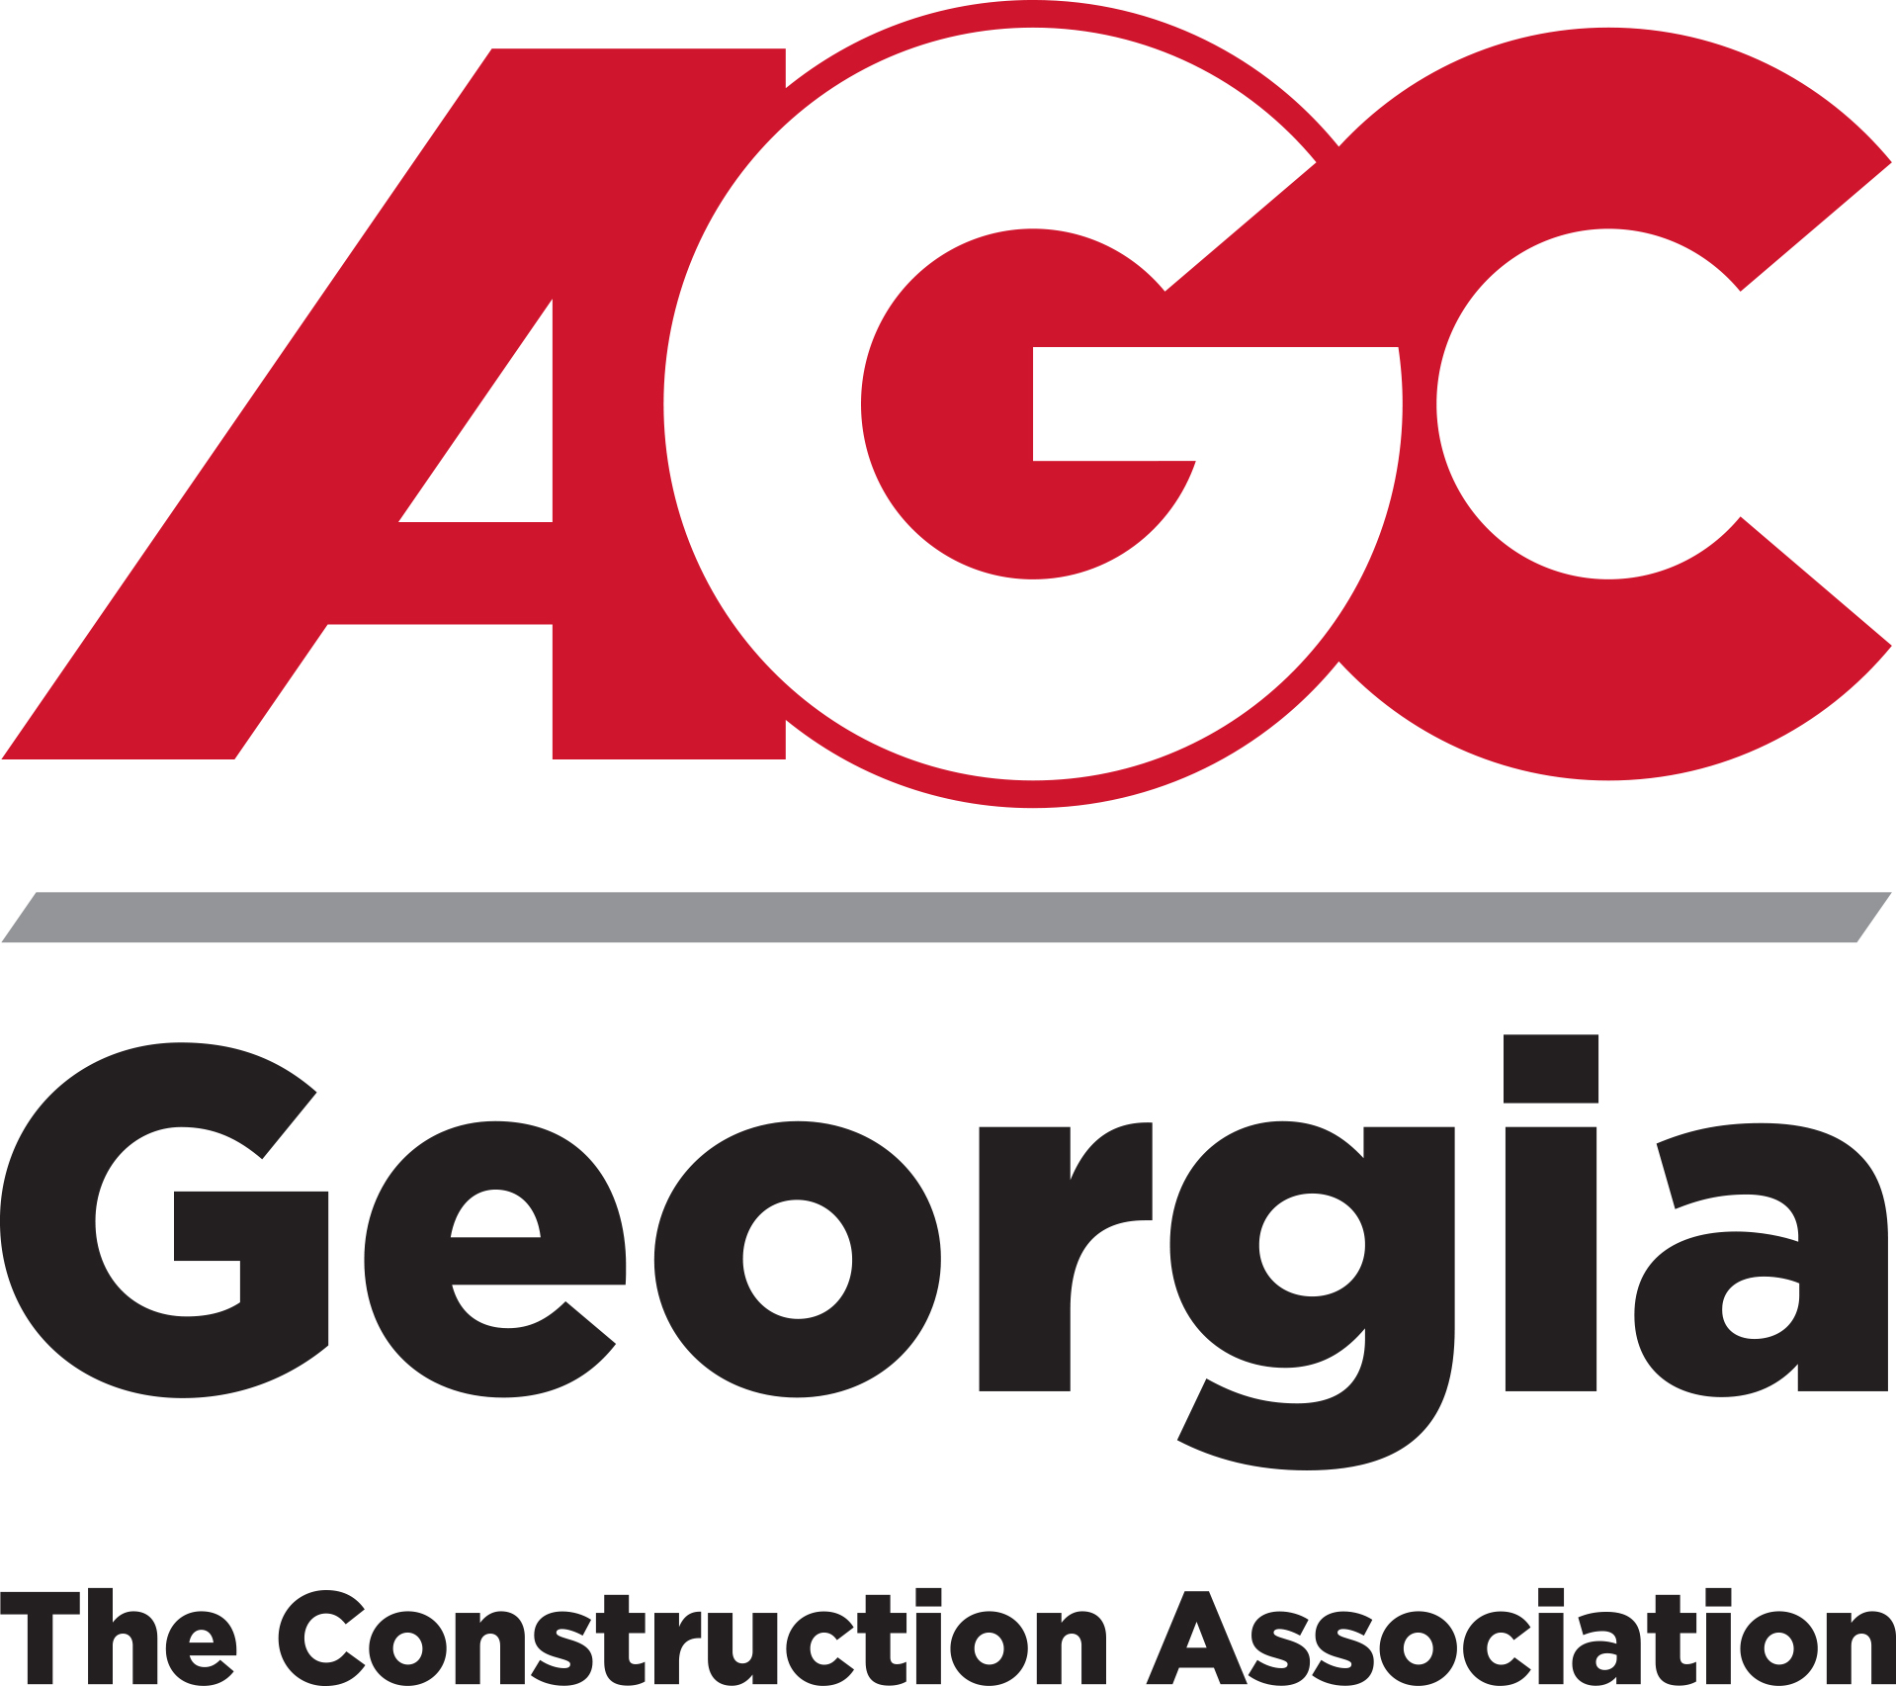
Press Contact:
Benjamin David
(678) 298-4136
david@agcga.org

AGC Georgia Announces Leadership Transition
Zach Fields assumes role of Chief Executive Officer; fifth in association’s 98-year history

ATLANTA (January 1, 2026) – AGC Georgia announces the leadership transition following the retirement of Mike Dunham, who concluded his service at the end of 2025 after 30 years with AGC Georgia and a total of 44 years with the Associated General Contractors of America organization.

Zach Fields joined AGC Georgia in January 2025 as Executive Vice President as part of a planned leadership succession to gain firsthand insight into the association’s operations while preparing to lead AGC Georgia into its next chapter.

“I am honored to step into this role and serve AGC Georgia’s members and team,” said Fields. “I look forward to building on the strong foundation created by those who came before us and carried forward by our staff, while upholding AGC Georgia’s principles of Skill, Integrity, and Responsibility. We will continue to advocate for the men and women whose hard work and dedication drives our industry, strengthens our communities, and supports families across the state.”

Zach Fields brings a strong background in construction education and workforce development. His passion for the industry began in high school as a construction student and competitor, laying the foundation for a career rooted in both hands-on experience and leadership. A University of Georgia graduate, he began his career in historic renovation and remodeling before transitioning into education, building a top-tier high school construction training program from the ground up. Throughout his career, he has worked closely with the AGC Georgia team on workforce development and legislative initiatives, strengthening collaboration and advancing opportunities for the industry.

Fields is married to his wife, Courtney, and is the father of four children. He enjoys all things building, gardening, reading, coaching youth sports, outdoor activities, and family time.

For more information about AGC Georgia, please visit agcga.org.

# # #

About AGC Georgia
AGC Georgia is a professional trade association and the statewide chapter affiliated with The Associated General Contractors of America Inc. (AGC of America). AGC Georgia member firms perform a majority of the public and private commercial construction work in Georgia and include approximately 650 of the top general contractors, residential/light commercial builders, construction managers, design-builders, municipal-utility contractors, heavy and highway contractors, specialty contractors, service providers, and suppliers. AGC Georgia is one of 88 chapters representing over 27,000 member firms nationwide. AGC of America is the largest and most respected construction trade association in the U.S. For more information, please visit www.agcga.org.

